Open the power shell as => Run as administrator.

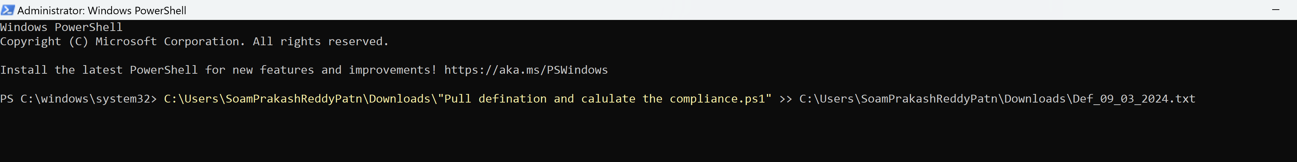

It will reads the data from the portal and it will appx take 11 minutes to get the 400+ records ( duplicate data will be present but correct one with respective to release dates.) from the defender portal.

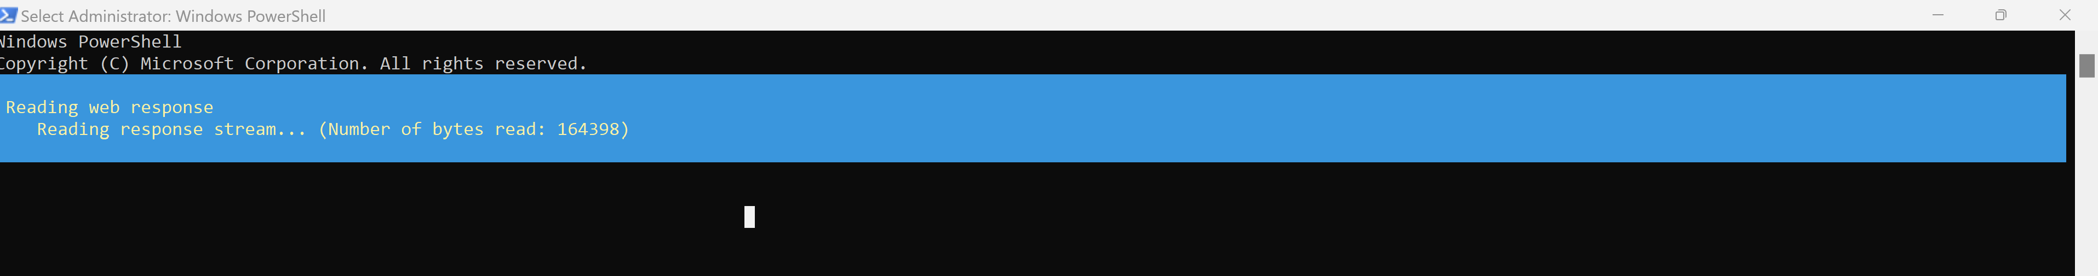

0Kb file got generated.

Post completion of script.

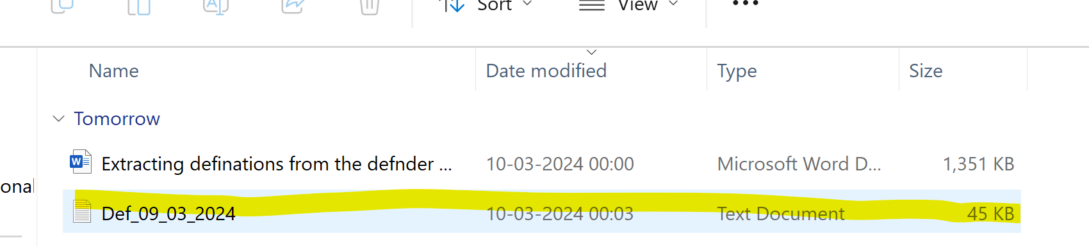

**Output file**

Now you can do ETL operation in excel